Sitecore Deployment

**The first Step, set-up TeamCity**

The first thing that I had to do was find under Teamcity the project that I wanted.

Then I had to create a new Attach VCS root . VCS means Version Control System . When we create a new Attach VCS root all we do is tell TeamCity to look at a repository. In this case we pointed Teamcity to an SVN repository (however it could have been another Version Control System such as Git). We then need to push our code from Visual Studio to that SVN repository.

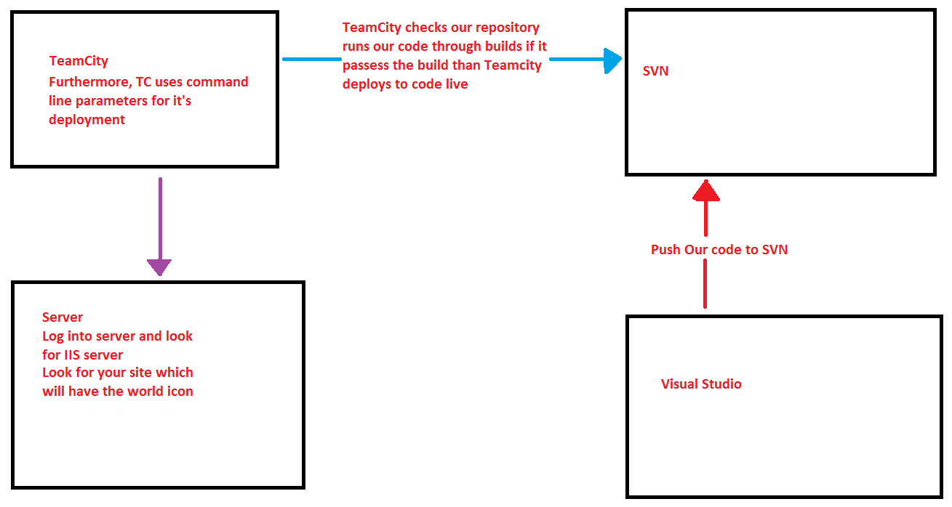

**The second step is to Configure the MSBuild step**

Once Teamcity knows about our repository. It’s Teamcity job to run our code in the repository through build tests. Each and every time a Developer submits code to the repository; our code will be tested through build tests to ensure that the repository does not break as a result of our commits. This is known as continuous integration.

* MSBuild usually occurs at the end after all of the builds. Since MSBuild we deploy to a Server.

We have to configure MSbuild’s Command line parameters, the important thing here is that Teamcity uses the Server’s IIS Server. In essence, when we push our code from Visual Studio to an SVN repository TeamCity’s MSbuild will check that our code works with the rest of the code in the repository. By study I mean that . If it is all chec TeamCity will also look at our web.config file. We specify MSBuild’s Command line parameters which informs TeamCity which web.config that Teamcity should use when deploying the Site to the Server.

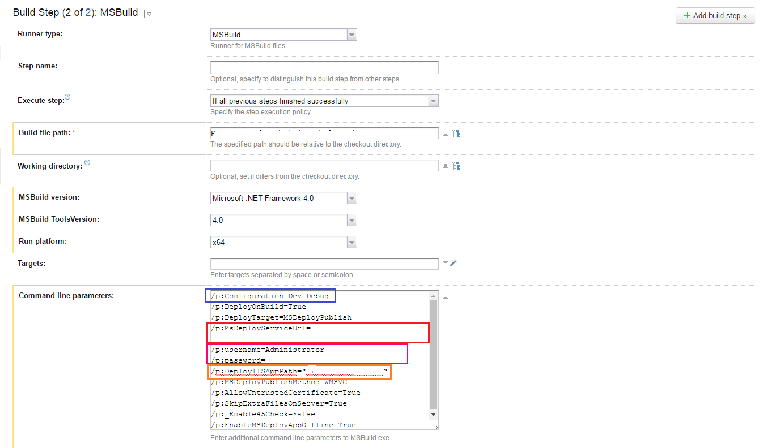

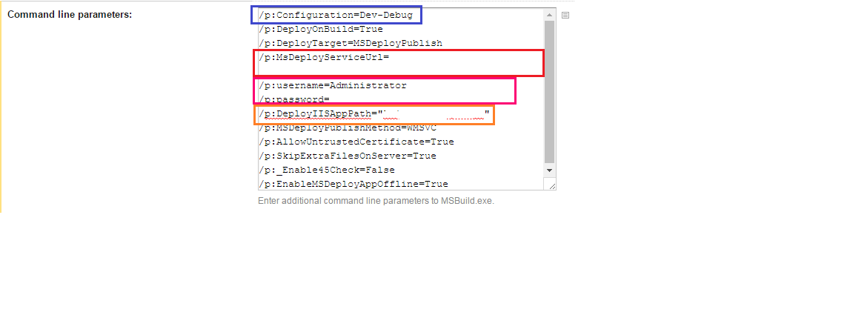

In the command line parameters the **first blue square** :

-> This demands Teamcity to use a specified version of web.config file called Dev-Debug during the deployment.

The **second red square:**

-> This tell Teamcity the Server that we are going to deploy to. This field it usually a http url-link to the Server.

**The third purple square:**

-> Are the user credentials for **the Server.**

**The fourth orange square:**

-> This relates to the name of the Site on the IIS server; where the project will be found on the Server

-> Check this by logging into the Server; using the Server credentials from the build parameters. Once you are logged into the Server open up IIS server manager and look for the Site which has the same name as that define in the **orange box above**. That is essentially where your code will be pushed.